**MORTGAGES**

* A mortgage is a loan used to purchase or maintain a home, plot of land, or other real estate. The borrower agrees to pay the lender over time, typically in a series of regular payments divided into [principal](https://www.investopedia.com/terms/p/principal.asp) and [interest](https://www.investopedia.com/terms/i/interest.asp). The property then serves as [collateral](https://www.investopedia.com/terms/c/collateral.asp) to secure the loan.
* The cost of a mortgage will depend on the type of loan, the term (such as 30 years), and the interest rate that the lender charges.
* Mortgage rates can vary widely depending on the type of product and the qualifications of the applicant.
* Individuals and businesses use mortgages to buy real estate without paying the entire purchase price upfront.
* Typical mortgage terms are for 15 or 30 years. Some mortgage terms are as short as five years, while others can run 40 years or longer.
* As of June 26, 2024, the average 30-year fixed mortgage rate is 6.89%, 20-year fixed mortgage rate is 6.58%, 15-year fixed mortgage rate is 6.07%, and 10-year fixed mortgage rate is 5.87%.
* Mortgage debt reached its highest point in 2021 when it totaled $17.6 trillion. The $82 billion increase from 2020, when mortgage debt was $16.78 trillion
* The rate on 30-year fixed mortgage rates hit an all-time weekly low in the first week of January 2021. That kicked off the best year overall for fixed mortgage rates in history, with 30-year fixed mortgages having an average of 2.96% interest and 15-year fixed rates averaging 2.27%.
* As of 2024, **Americans owe $12.14 trillion on 84.0 million mortgages.** That comes to an average of $144,593 per person with a mortgage on their credit report. Mortgages represent 70.2% of consumer debt in the U.S.
* 2.6% of mortgage accounts were at least 30 days past due and 1.2% were at least 90 days past due in August 2023.
* **In the second quarter of 2023, 2.0% of mortgages — or 1.1 million residential properties — were “underwater.”**That means that the outstanding mortgage balance is greater than the estimated sale price of the home
* **The average size of a home purchase mortgage obtained through the LendingTree platform in the 12 months ending in October 2023 was $224,398.**Average loan sizes were highest in Hawaii ($464,994), the District of Columbia ($355,986) and Massachusetts ($309,490).
* **1.2% of mortgages were seriously delinquent or in foreclosure as of August 2023.** That means they’re 90 days or more past due. 4.6% of Federal Housing Administration (FHA) and 2.5% of Veterans Affairs (VA) loans were seriously delinquent or in foreclosure as of October 2022 (the latest data available)
* The average purchase price for a home in the U.S. — including [down payments](https://www.lendingtree.com/home/mortgage/average-down-payments-study/) — was dramatically higher than the $224,398 average mortgage size on our platform between November 2022 and October 2023.

|  |  |
| --- | --- |
| **Quarter** | **Average Home Price** |
| Q1 2012 | $270,000 |
| Q1 2013 | $290,000 |
| Q1 2014 | $320,000 |
| Q1 2015 | $360,000 |
| Q1 2016 | $390,000 |
| Q1 2017 | $430,000 |
| Q1 2018 | $470,000 |
| Q1 2019 | $495,000 |
| Q1 2020 | $515,000 |
| Q1 2021 | $550,000 |
| Q1 2022 | $590,000 |
| Q1 2023 | $570,000 |
| Q3 2023 | $550,000 |

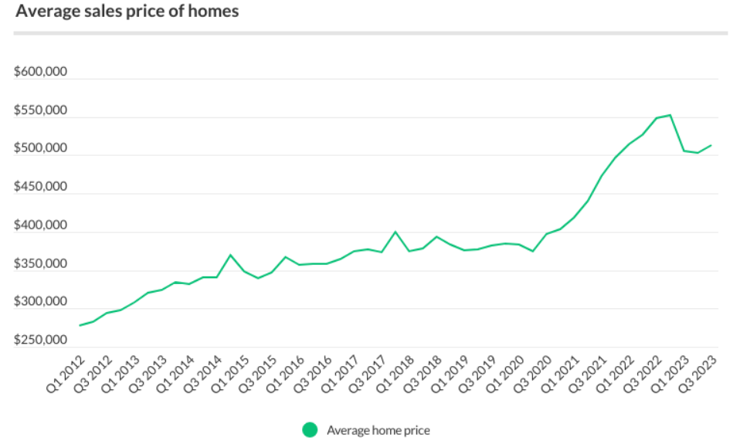

**AUTO LOANS**

* An [auto loan](https://www.investopedia.com/best-auto-loan-rates-4846394) is a type of [secured loan](https://www.investopedia.com/secured-loans-5076025) for purchasing a car or other vehicle. The vehicle itself serves as collateral for the loan and can be [repossessed](https://www.investopedia.com/what-happens-if-i-don-t-pay-my-car-loan-7557588) by the lender if the borrower [defaults](https://www.investopedia.com/terms/d/default2.asp). Auto loans today come in many different terms, or lengths, typically ranging from 36 to 72 months, but sometimes up to 96 months.
* Credit score can play a major role in the interest rate we will have to pay.
* While there is no official minimum credit score to qualify for an auto loan, we will likely need a [credit score of 661 or higher](https://www.investopedia.com/what-credit-score-do-you-need-to-buy-a-car-5181034) to obtain a loan with a good interest rate.
* We can get an [auto loan](https://www.investopedia.com/best-auto-loan-rates-4846394) for a new car or used car. The interest rate for a used car loan is typically higher than one for a new car.
* Over 80% of new cars and over 37% of used cars were financed in Q1 of 2024.
* PenFed Credit Union is the best overall auto loan lender thanks to its wide selection of loan types and competitive rates, according to research. It offers rates for used cars as low as 6.49%, and another one of our picks, OpenRoad Lending, offers refinance rates as low as 1.99%.
* Auto loan debt held by Americans rose to a record $1.62 trillion in the first quarter of 2024, making it one of the major sources of consumer debt for 2024.
* Auto loans is the second-largest debt category behind mortgages.
* the interest rate has soared in the months after that, reaching 7.9 percent in February 2024.
* the number of originations, or new loans, remained flat from the previous year. TransUnion reported that the number of [originations](https://www.investopedia.com/terms/o/origination.asp) was 5.8 million in the first quarter of 2024 and during the same period in 2023. TransUnion reported that high interest rates and inflation, make the affordability of automobiles difficult.
* Americans have had difficulty keeping up with payments on auto loans, where about 5% of the auto loan balance of borrowers was 90 days or more delinquent. This level has remained fairly flat from 2021.
* Year-over-year growth in average used auto loan amount at finance companies rose to 15.39%.
* Texas is leading with $29,164 while in other states the auto loan volume remains lower and a moderate increase is seen.
* Credit unions are responsible for 25.8% of all auto loans and 26.7% of new auto loans. Although they operate in a similar way to banks, they are nonprofit organizations owned by the depositors.
* The first major player in the auto loan industry was General Motors Acceptance Corporation (GMAC), the financing arm of GM, which was created in 1919. Consumers had to pay 35% down and pay the balance within a year.
* Domestic banks have started to ease their tightening measures. In second quarter of 2023, these measures peaked at 27.5, but they have gradually decreased since then, reaching a low of 6.3.
* Over the last decade, interest rates have generally remained within the range of 4.00% to 5.5%. However, experiencing an 8% surge in the third quarter of 2023 is considered significant.

|  |  |
| --- | --- |
| **Year** | **Percentage Change** |
| 2012 | 20% |
| 2013 | 22% |
| 2014 | 25% |
| 2015 | 10% |
| 2016 | 15% |
| 2017 | 5% |
| 2018 | 0% |
| 2019 | -10% |
| 2020 | -5% |
| 2021 | -15% |
| 2022 | -30% |
| 2023 | -40% |
| 2024 | -20% |